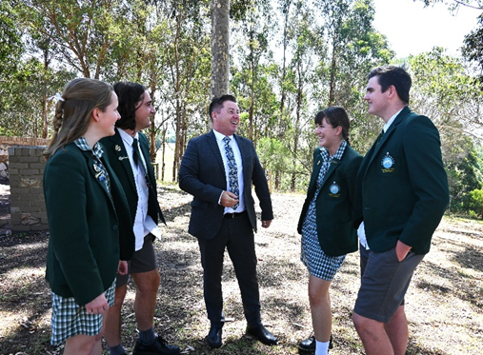

**Role Outline: POL 4 20 Periods**

The Director of Students is appointed by Nagle College and is responsible to the Deputy Principal Students.

The Director of Students is co-responsible for developing Catholic identity and the educational mission of Nagle College within the Mission of the Church.

At Nagle College, we have two key Leadership Teams – the Executive Strategic Leadership Team which consists of the Principal team and the Middle Leadership Team which consists of the POL team.

The Director of Students is a vital role in ensuring the successful transition of strategic direction in relation to pastoral care and pastoral education. The Director of Students will ensure that all House Leaders are aware of how each student in their House Groups are guided to achieve their personal best, making use of relevant pastoral and academic data.

The Director of Students will lead the team of seven House Leaders in implementing and developing the Whole School Approach to Positive Behaviour, ensuring that Nagle College succeeds as a continually evolving Community of Practice.

As a member of the Middle Leadership Team, they are part of the engine room that makes strategy become successful practice. This is achieved through their collaboration with the Executive Strategic Leadership Team, Deputy Principal Students and House Leaders and families.

**Application:**

Applications Packs can be received by emailing an Expression of Interest to [HR@nagle.vic.edu.au](mailto:HR@nagle.vic.edu.au)

**Our Vision:**

Inspired by the life of Christ, our Presentation Heritage and the Salesian Charism, Nagle College is a Catholic community that welcomes, builds strong relationships, evangelises and prepares young people for life.

**Our Expectations:**

Our College is a Catholic faith-based learning community that ensures all students can be **Safe**, **Happy** and **Successful**. Students are reminded of this through the continuous implementation of our College’s school wide expectations: Respect, Responsibility and Excellence.

As a Catholic community we are people of hope, which is based on developing successful and respectful relationships between staff, students and families, following the example of Jesus Christ.

Director of Students – Middle Leadership Team POL 4 20 Periods

