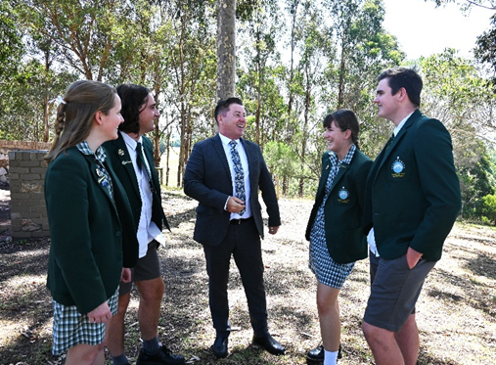

**Role Outline: POL 4 20 Periods**

The Director of Applied Learning is appointed by Nagle College and is responsible to the Deputy Principal Students.

The Director of Applied Learning is co-responsible for developing Catholic identity and the educational mission of Nagle College within the Mission of the Church.

At Nagle College, we have two key Leadership Teams – the Executive Strategic Leadership Team which consists of the Principal team and the Middle Leadership Team which consists of the POL team.

The Director of Applied Learning is a vital role in ensuring the successful transition of strategic direction in relation to Applied Vocational Learning. The Director of Applied Learning will oversee and lead the implementation of vocational and entrepreneurial education at Nagle College.

The Director of Inclusive Practice will lead a team of VM teachers to ensure that they have the resources, skill development and support required for them to succeed in VM, VPC and VET, as well as exploring and implementing vocational learning for students who desire such a vocational pathway throughout middle school years.

As a member of the Middle Leadership Team, they are part of the engine room that makes strategy become successful practice. This is achieved through their collaboration with the Deputy Principal Learning and Teaching, House Leaders, Multi-Agencies and employers, as well as being the key contact for vocational students’ families.

**Application:**

Applications Packs can be received by emailing an Expression of Interest to [HR@nagle.vic.edu.au](mailto:HR@nagle.vic.edu.au)

**Our Vision:**

Inspired by the life of Christ, our Presentation Heritage and the Salesian Charism, Nagle College is a Catholic community that welcomes, builds strong relationships, evangelises and prepares young people for life.

**Our Expectations:**

Our College is a Catholic faith-based learning community that ensures all students can be **Safe**, **Happy** and **Successful**. Students are reminded of this through the continuous implementation of our College’s school wide expectations: Respect, Responsibility and Excellence.

As a Catholic community we are people of hope, which is based on developing successful and respectful relationships between staff, students and families, following the example of Jesus Christ.

Director of Applied Learning – Middle Leadership Team POL 4 20 Periods

